LAB 1

PART-A:

Pwd : present working directory
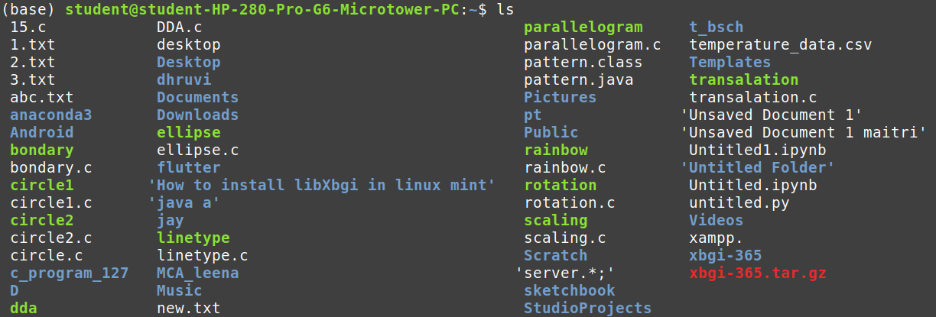
ls : give the list of directories

mkdir : to create directory
--help : to get info and options of a command
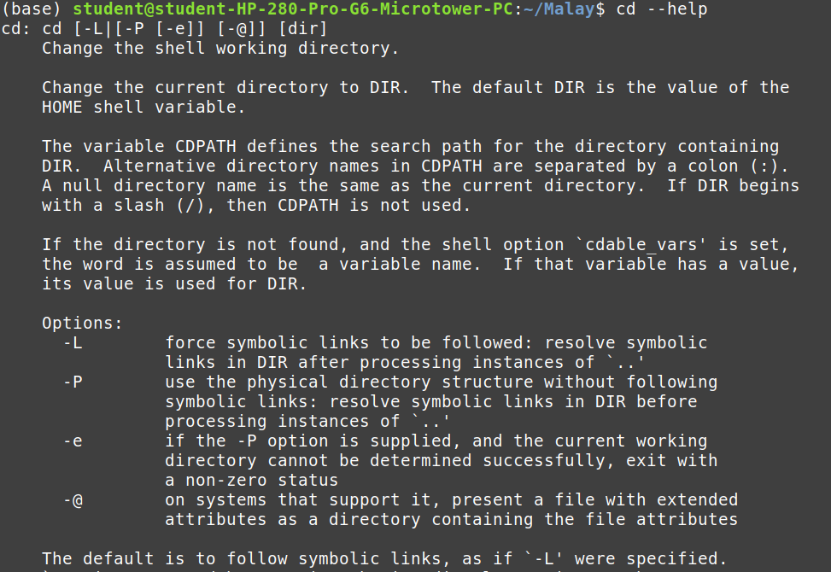

date : to display current date and time
cal : to display calendar of current month
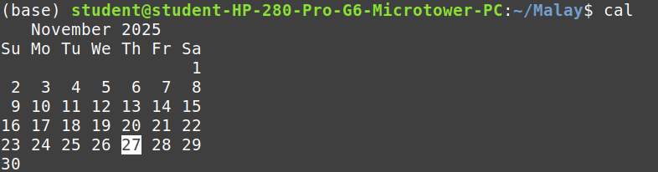
cat : to create and write in file
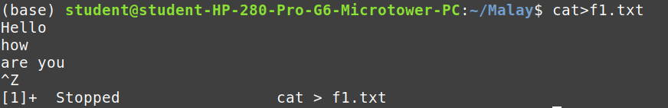

echo : work as printf
>> :
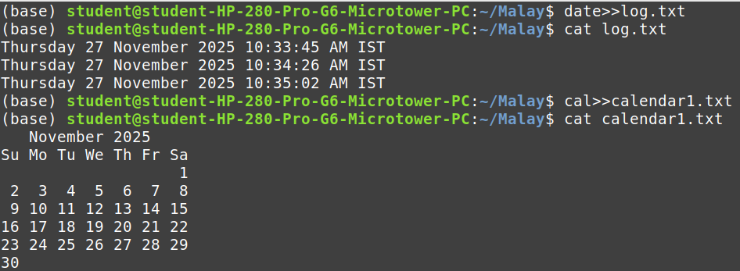

PART-B:

Print date and time in custom format
combine two files:
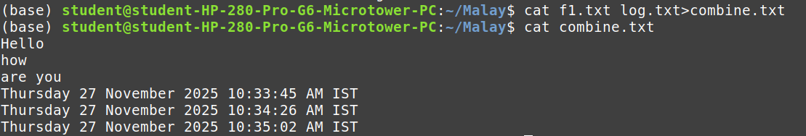
make file with current date and store date in it
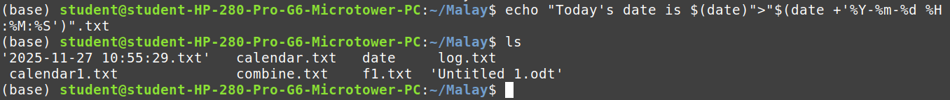

PART-C:

1.

2.

